|  |
| --- |
| **Name: Vishnu Mohan**  **Roll No: 51**  **Batch: R MCA B**  **Date: 03-06-2022** |

**ADVANCED DATABASE MANAGAMENT SYSTEM LAB**

**Experiment No.: 9**

# Aim

To create database in MongoDB & practice its CRUD operations.

**Procedure:**

1. Display available Databases and selecting the desired database.

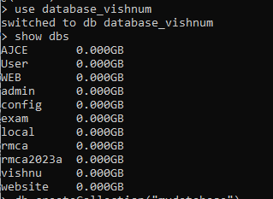

2. Creating collection in the database.



3. Insertion of fields

a. InsertOne: Inserts entered queried documents into the collection.

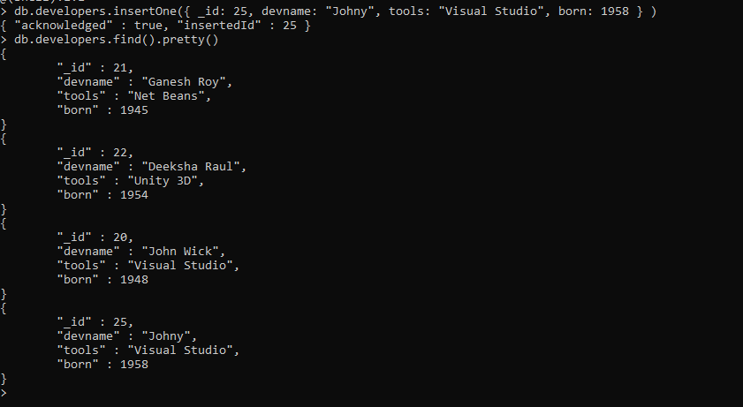

b. Insert Many: Insert Multiple documents into the collection at same time

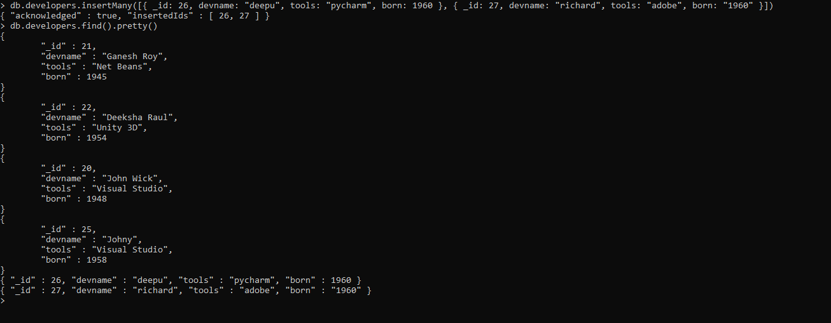

4. Find fields and documents using filters

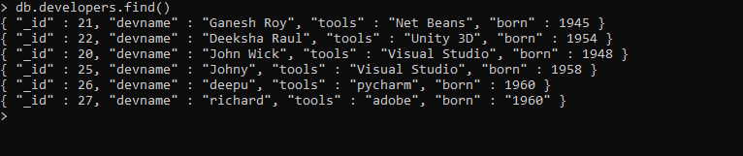

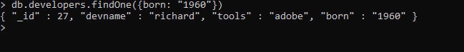

5. Update fields according to the filter query conditions

a. UpdateOne: Updates only one document.

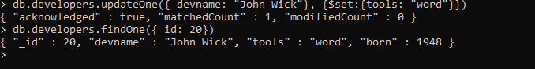

b. UpdateMany: Updates multiple documents according to the query from the collection

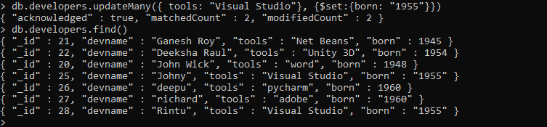

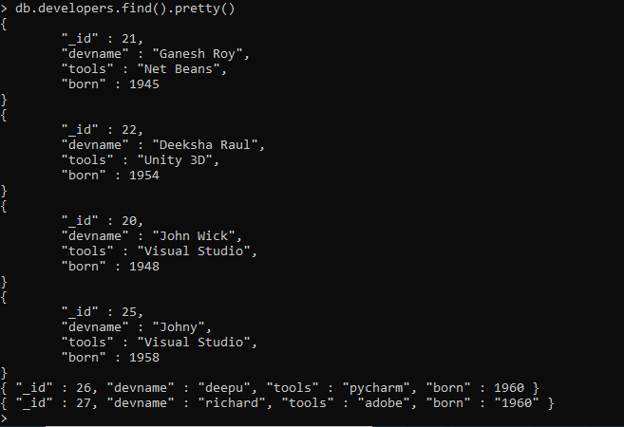

6. replaceOne: Replace the whole specified document with the new values.

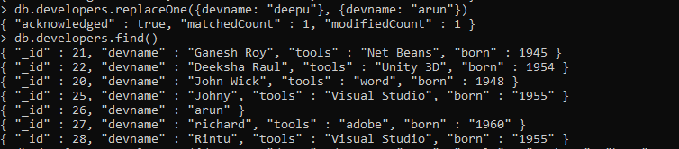

7. Delete documents according to specified conditions.

a. DeleteOne: Deletes only one documents according to the condition.

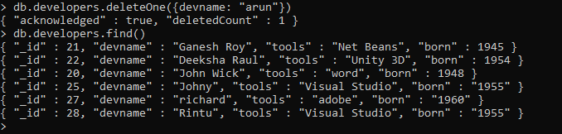

b. DeleteMany: Deletes all the documents that satisfies the condition.

